**SUPERBLOCK RECOVERY**

When we get this type of request,

we need to check the three major spots of file system

1. File system is in read only mode
2. File system is in-consistency

3. Disk fail or super block corrupted

we need check the hard disk, the disk is available or not by using command

#lsblk

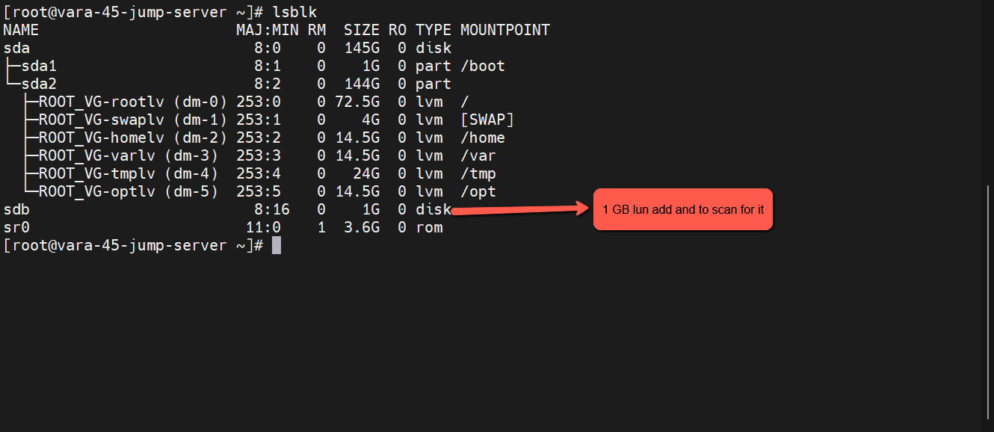

The disk is available here.

we need to check the filesystem configuration file #/etc/fstab

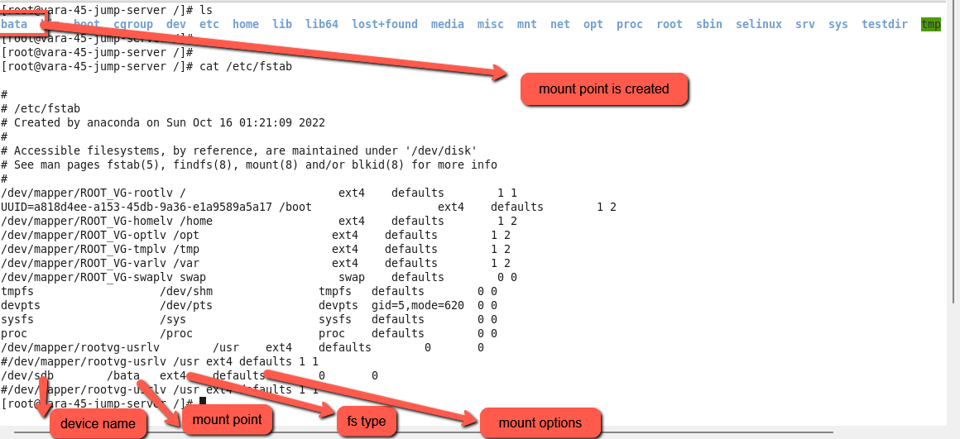

In this configuration file the entries are fine but why disk file system is not mounted.

but having a for read and write.

We find the mounted file system information by using command

#df -h

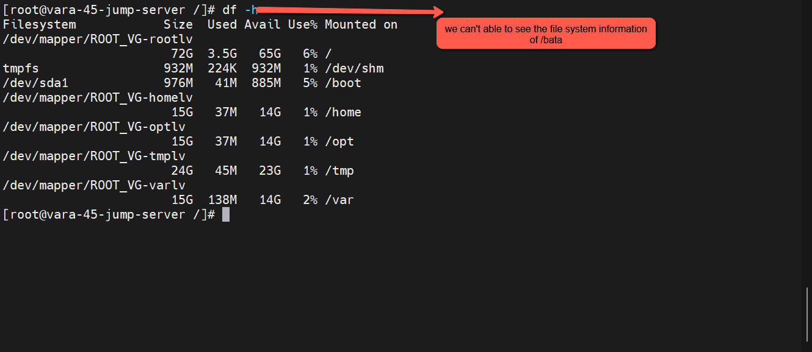

Disk is available, disk and mount point information in the #/etc/fstab configuration file also available.

But file system type is not available on the disk to check for it by using command

#blkid

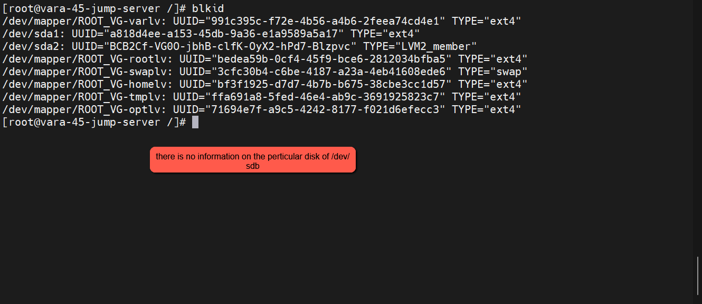

Mount the mount point by using command

#mount /bata

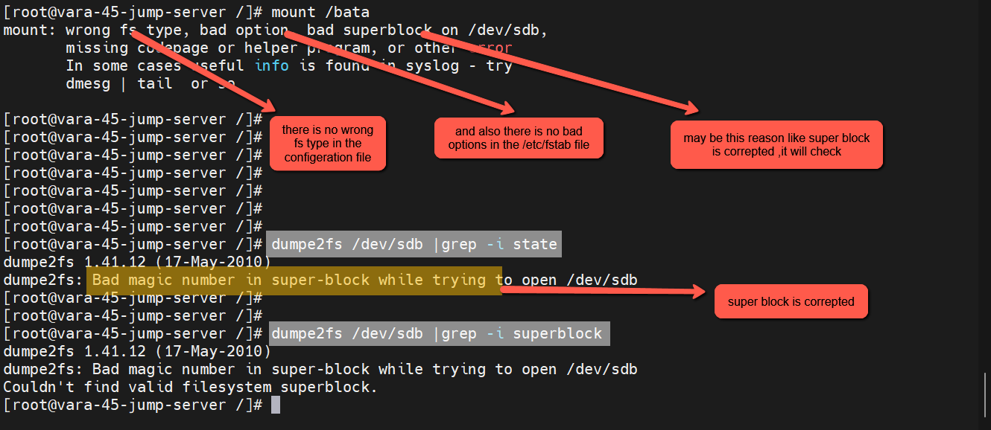

In this command will give an error message and let us to identify the problem.

There is no wrong fs type and no bad option and we will check the super block may be corrupted.

We can check disk state by using command

#dumpe2fs <device name> | grep -I state

This command will give disk information, super block is corrupted or not.

**Note: super block is corrupted**

This issue is rectified through replace with backup super block on the disk.

We can identify the remaining superblocks on the disk by using command

#mke2fs -n <device name>

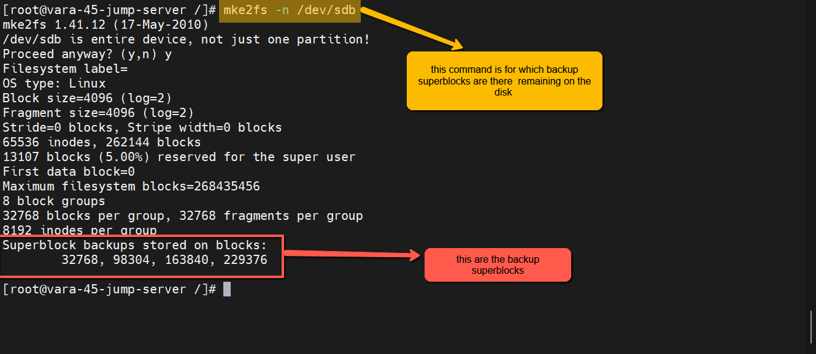

Restore the disk information with attached another super block.

Before using this command first, we need to proper approval from the customer, because data may be lost. once confirmation from the customer we will follow the process.

**#fsck -y -b <super block> /dev/sdb**

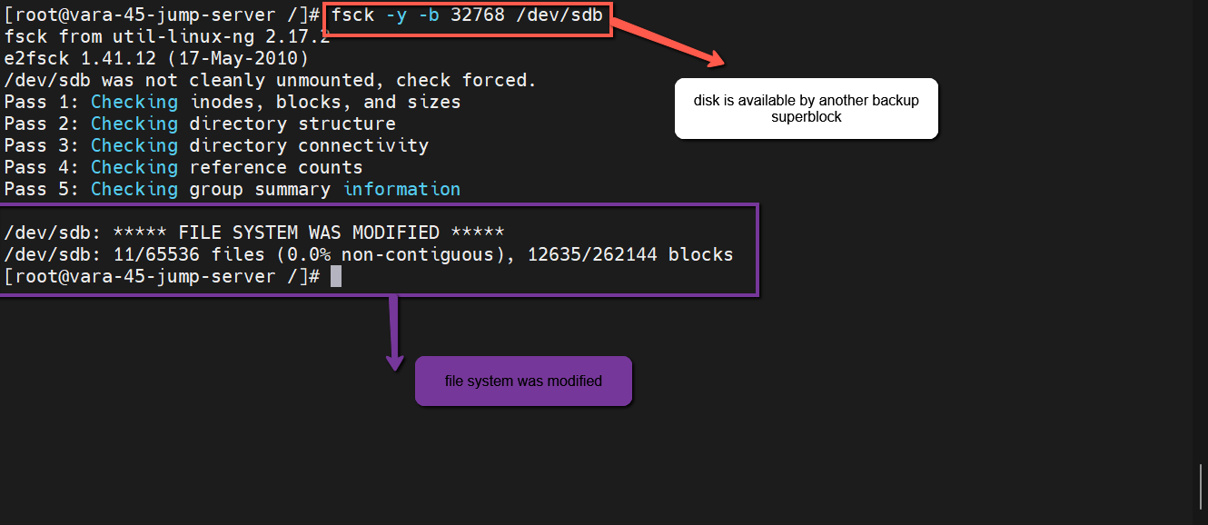

To fire this command on the disk, the file system was modified.

The disk state is in clean

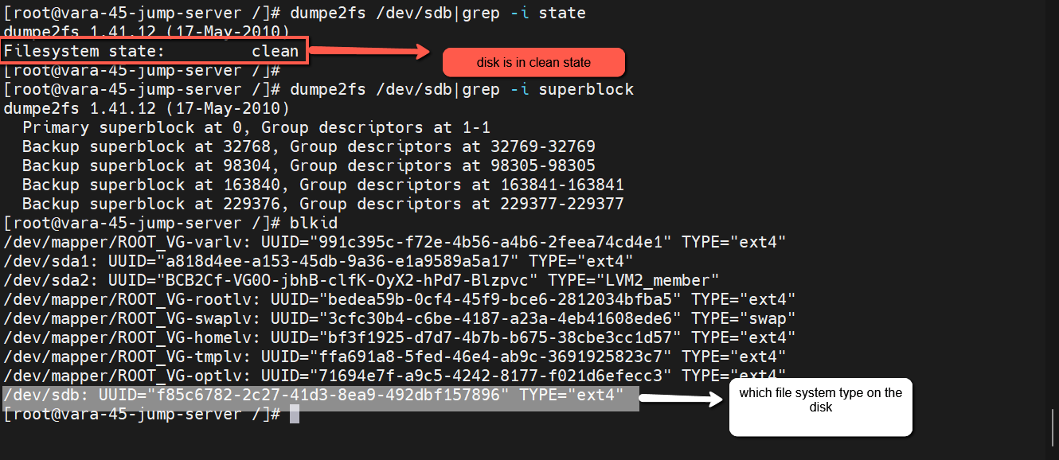

And we will restore data on the disk.

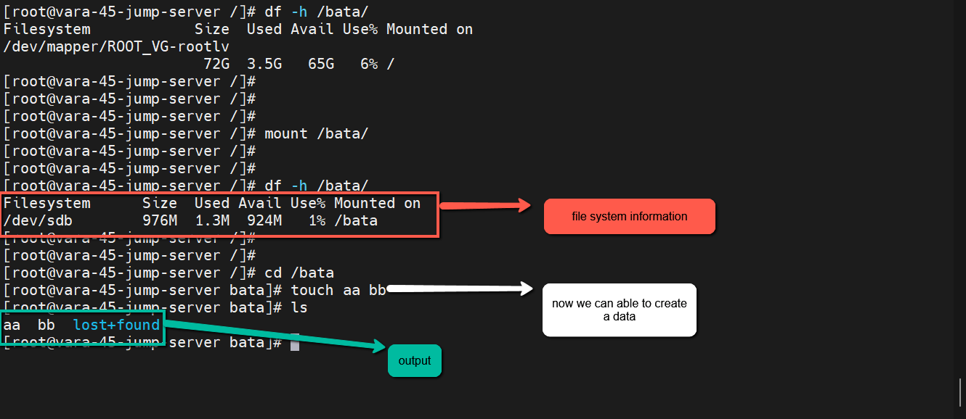

All the disk information is maintained by super block, if incase the super block is corrupted, the disk does not work properly and lost the customer data also. In this scenario we use all above procedure.